**COOKBOOK**: YOUR VIRTUAL KITCHEN ASSISTANT

**(REACT APPLICATION)**

**INTRODUCTION:**

CookBook: Your Virtual Kitchen Assistant is your ultimate digital cooking companion, designed to simplify meal planning and enhance your culinary experience. Whether you're searching for new recipes, organizing your favorite dishes, or discovering personalized meal suggestions, CookBook makes cooking easier and more enjoyable. With an intuitive interface, step-by-step instructions, and smart ingredient management, this Reactpowered app ensures that every meal is a success. From beginner cooks to seasoned chefs,

CookBook is here to inspire and assist you in the kitchen—one recipe at a time!

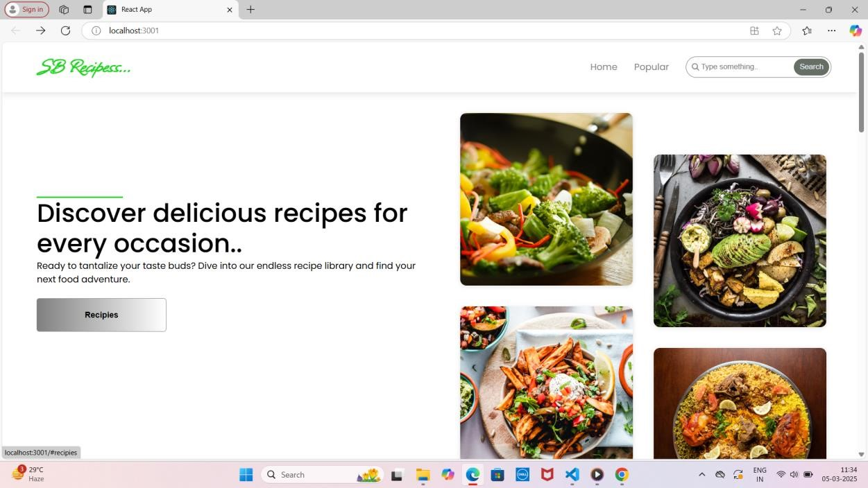

**Description:**

CookBook is a React-based web application designed to make cooking effortless and enjoyable. It allows users to explore a vast collection of recipes, save their favorite dishes, and organize ingredients efficiently. With smart search functionality, step-by-step cooking instructions, and personalized meal recommendations, CookBook caters to both beginners and experienced chefs. The app also features an intuitive user interface, meal-planning tools, and grocery list integration to streamline the cooking process. Whether you're looking for quick weeknight dinners or gourmet creations, Cook Book is your perfect kitchen companion.

Beyond just a recipe manager, CookBook offers smart features like personalized meal recommendations, ingredient substitutions, and grocery list generation. The app helps users optimize their kitchen experience by suggesting meals based on available ingredients, dietary preferences, and cooking time. With built-in search functionality and filter options, finding the perfect recipe is quick and hassle-free.

CookBook is designed to be a seamless and interactive cooking assistant for users of all skill levels. Its responsive design ensures accessibility across devices, allowing users to browse and follow recipes from their desktop, tablet, or mobile phone. Whether planning meals for the week or trying out a new dish, CookBook is your go-to kitchen companion, making cooking more enjoyable, efficient, and stress-free.

From hearty breakfasts to indulgent desserts, each recipe is crafted with love, using simple ingredients that bring people together. With step-by-step instructions, cooking tips, and vibrant photos, *Flavors of Home* makes it easy to create unforgettable meals for family and friends.

Cooking is more than just preparing food—it’s an experience that brings people together. *The Ultimate Cookbook* is your go-to guide for creating mouthwatering meals, whether you're cooking for a cozy family dinner or a festive gathering. With a diverse collection of recipes ranging from quick and easy weekday meals to impressive dishes for special occasions, this book is designed to inspire both beginners and seasoned cooks alike. Each recipe is carefully crafted with simple ingredients, step-by-step instructions, and helpful tips to ensure success in the kitchen.

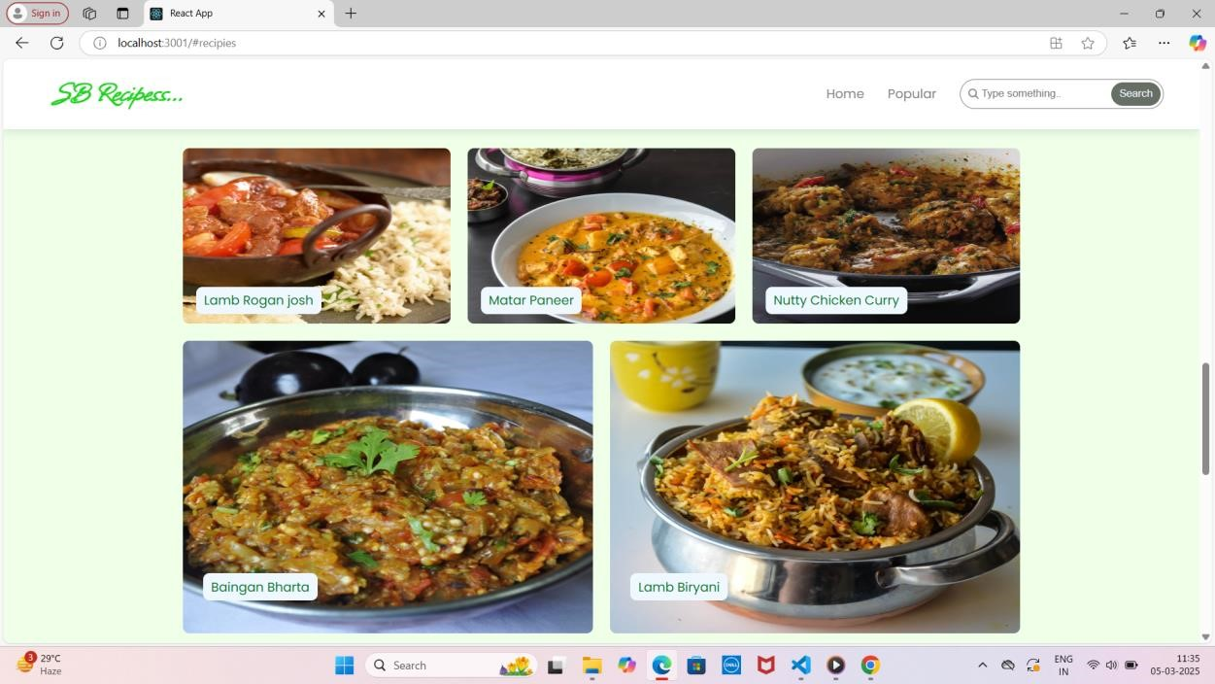

**SCENARIO: A Busy Professional Planning a Healthy Dinner**

Emma is a busy marketing executive who loves cooking but struggles to plan meals after long work hours. One evening, she opens **CookBook: Your Virtual Kitchen Assistant** on her phone, looking for a quick and healthy dinner idea. She uses the **smart search feature** to filter recipes by “under 30 minutes” and “high-protein.” Within seconds, she finds a **grilled salmon with quinoa salad** recipe that fits her preferences.

Before heading to the kitchen, Emma checks her pantry and realizes she’s out of quinoa. Luckily, Cook Book suggests **alternative ingredients**, recommending brown rice as a substitute. She updates her grocery list within the app and makes a mental note to pick up quinoa on her next shopping trip. As she cooks, she follows the **step-by-step instructions** on her tablet, using the app’s built-in **timer and measurement converter** to ensure accuracy.

After enjoying her delicious meal, Emma saves the recipe to her “Quick & Healthy” collection for future reference. She also rates the dish and leaves a note about adding extra lemon juice for more flavor. Thanks to CookBook, Emma has not only prepared a nutritious meal with ease but has also streamlined her meal-planning process—making healthy eating more convenient despite her busy schedule.

**TECHNICAL ARCHITECTURE:**

The user experience starts with the CookBooks web application's UI, likely built with a framework like React or Vue.js for a smooth, single-page experience. This UI interacts with an API client specifically designed for CookBooks. This client handles communication with the backend, but with a twist: it leverages Rapid API, a platform providing access to various external APIs. This suggests CookBooks might integrate external data feeds or functionalities through Rapid API, enriching the user experience without building everything from scratch.

**PROJECT GOALS AND OBJECTIVES:**

* **Simplify Meal Preparation** – Provide an intuitive and user-friendly platform that helps users explore, organize, and follow recipes effortlessly.
* **Enhance Cooking Experience** – Offer smart features such as ingredient substitutions, grocery list integration, and step-by-step instructions to make cooking more efficient.
* **Promote Healthy and Personalized Eating** – Allow users to filter recipes based on dietary preferences, available ingredients, and nutritional needs.
* **Ensure Accessibility and Convenience** – Design a responsive React application that works seamlessly across desktop, tablet, and mobile devices.
* **Encourage User Engagement** – Enable users to save favorite recipes, leave ratings, add personal notes, and share meal ideas with others.
* Develop a **React-based web application** with a clean and responsive UI.
* Implement a **dynamic recipe database** with search and filter functionalities.
* Integrate a **smart grocery list** feature to help users manage ingredients efficiently.
* Provide **step-by-step cooking guidance** with timers, measurement conversions, and voice-assisted instructions.
* Enable **personalized meal recommendations** based on user preferences, cooking habits, and dietary restrictions.
* Ensure **data storage and synchronization**, allowing users to access their saved recipes and lists across multiple devices.
* Maintain a **scalable and secure backend** to support future feature expansions, such as user-generated recipes and community interactions.

**FEATURES OF COOKBOOKS:**

* **Recipe Discovery & Search** – Explore a vast collection of recipes with advanced search and filter options based on cuisine, ingredients, cooking time, and dietary preferences.
* **Personalized Recipe Recommendations** – Get AI-powered meal suggestions tailored to your tastes, past selections, and available ingredients.
* **Grocery List Integration** – Automatically generate shopping lists based on selected recipes and keep track of pantry items.
* **Step-by-Step Cooking Instructions** – Follow detailed, easy-to-read cooking guides with timers, images, and video tutorials for better accuracy.
* **Ingredient Substitution Suggestions** – Receive smart alternatives when missing ingredients to help adapt recipes without extra shopping.
* **Meal Planning & Scheduling** – Plan meals for the week by organizing recipes into a built-in meal calendar.
* **User Accounts & Recipe Collections** – Save, categorize, and manage your favorite recipes in personalized collections.
* **Nutritional Information & Dietary Filters** – View calorie counts and macronutrient details while filtering recipes based on dietary needs (vegan, keto, gluten-free, etc.).
* **Interactive Cooking Tools** – Use built-in timers, measurement converters, and voiceassisted guidance for a seamless cooking experience.
* **Cross-Device Accessibility** – Access saved recipes, meal plans,and grocery lists on any device, ensuring convenience whether at home or on the go.

**PROJECT STRUCTURE:**

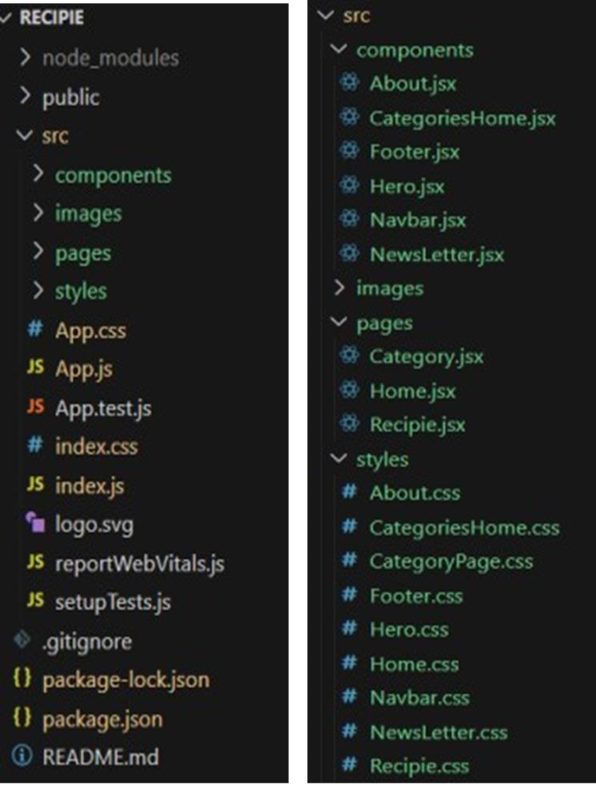

In this project, we’ve split the files into 3 major folders, *Components, Pages and Styles.* In the pages folder, we store the files that acts as pages at different url’s in the application. The components folder stores all the files, that returns the small components in the application. All the styling css files will be stored in the styles folder.

**LANGUAGE USED:**

Hypertext Markup Language (HTML) is the industry-standard markup language for developing web apps and pages. It is one of three foundational technologies underpinning the

World Wide Web, along with JavaScript and Cascading Style Sheets (CSS). HTML documents are downloaded from a web server or local storage by web browsers, who then turn them into multimedia web pages. HTML originally featured cues for the document's design and semantically explains the structure of a web page. The foundation of HTML pages are HTML components. Images and other objects, like interactive forms, may be embedded within the produced page using HTML techniques. By indicating structural semantics for text elements like headings, paragraphs, lists, links, quotations, and other objects, HTML offers a way to generate structured texts.

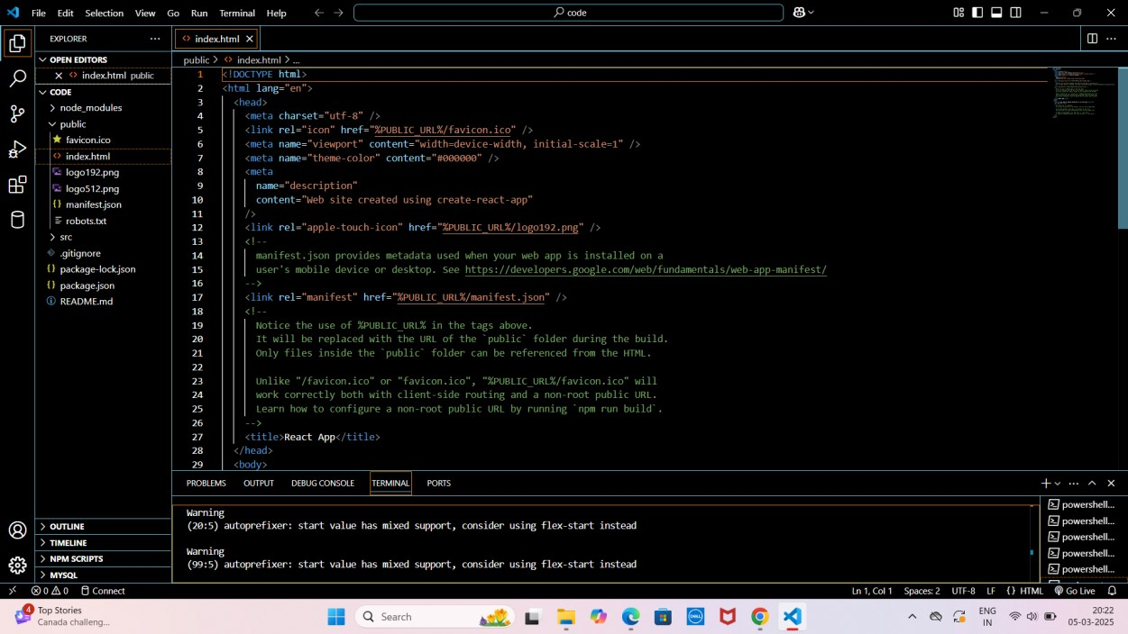

Cascading Style Sheets (CSS) is a language for creating style sheets that describe how a document produced in a markup language like HTML will look. The World Wide Web's foundational technologies, along with HTML and JavaScript, include CSS. Layout, color, and font may all be separated from content and presentation using CSS. By describing the pertinent 10 CSS in a separate CSS file, this separation can make content more accessible, give definition of presentation features greater freedom and control, allow numerous web pages to share formatting, and reduce complexity and repetition in structural content.

Visual Studio Code (VS Code) can be effectively used for writing project documentation due to its powerful text editing features, built-in Markdown support, and a wide range of extensions that allow for rich formatting, previewing, version control, and streamlined collaboration with developers.

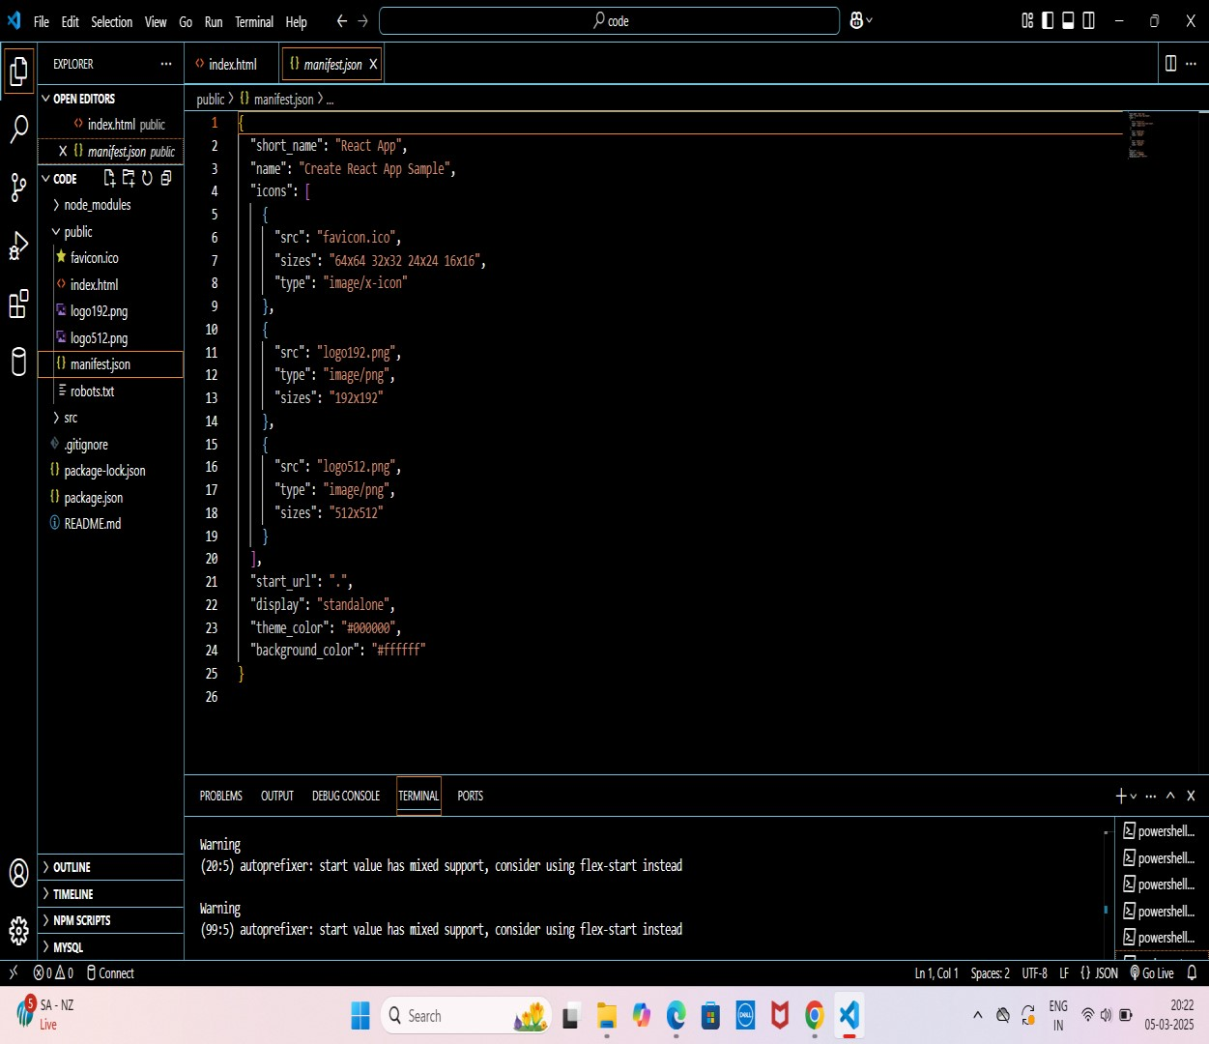

JavaScript often abbreviated as JS, is an interpreted, high-level programming language. Additionally, it is a dynamic, weakly typed, prototype-based, and multi-paradigm language. One of the three fundamental technologies of the World Wide Web, together with HTML and CSS, is JavaScript. JavaScript is a crucial component of online applications because it makes web pages interactive. The vast majority of websites make use of it, and every significant web browser has an engine specifically designed to run JavaScript.

THANK YOU

BY

ABIRAMI N

HARMITHAA SRI S P

KOMATHI S

HARIPPRIYA M

HARIPRIYA N